**EXPERIMENT NO. 7**

**Introduction to packet tracer and implementation of Hub and Switch**

**Aim:** Implementation of Hub and Switch using Packet Tracer

**Objectives:**

1. Familiarize with Cisco Packet Tracer tool.

2. Overview of ARP and ICMP.

3. Configuring devices in Packet Tracer. Configuring hosts and switches.

4. Observe difference in operation of a hub and a switch.

**Tool:**

Cisco packet tracer is a network simulator. It has a very simple and intuitive GUI. This simulator is a Cisco product specific and provides a platform to test networking concepts using virtual components.

Features:-

1. Real-time Simulation Modes
2. Logical Topology and Physical Modes
3. Portable can be installed in laptops also.
4. Global Packet Sniffer called “Event Viewer”; Adjustable Windows
5. RIP v1, RIP v2, EIGRP, ICMP, ARP, CDP, DHCP, NAT, IP
6. Ethernet, VLANs, 8021q, Inter-VLAN Routing, Frame Relay, PPP,
7. HDLC

Limitations:-

1. No ISDN, DSL, Cable Modem.
2. Doesn’t debug OSPF packets.
3. Limited TCP.
4. Doesn’t support all the functionalities of HTTP, FTP, DNS, Telnet.

**Scenarios:**

Implement the following scenarios one at a time

1. Place the clients and network components (generic hub and 2950-24 switch) as shown in figures below.

2. Use straight through cables from the options in lower menu bar.

3. Straight through cables are used to connect dis-similar components.

4. Use IP addresses as given in table below.

5. If all connections and IP addresses are fed correctly the lights on link-ends will turn green. If any other color shows up then troubleshoot it.

6. While setting up scenario 2, wait for the lights to turn green. It takes a while for the switch to configure connections with clients.

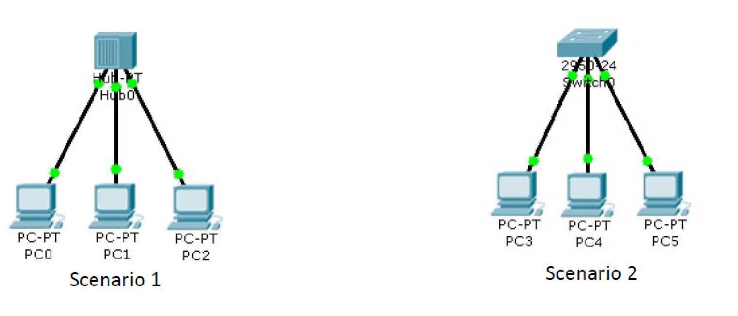

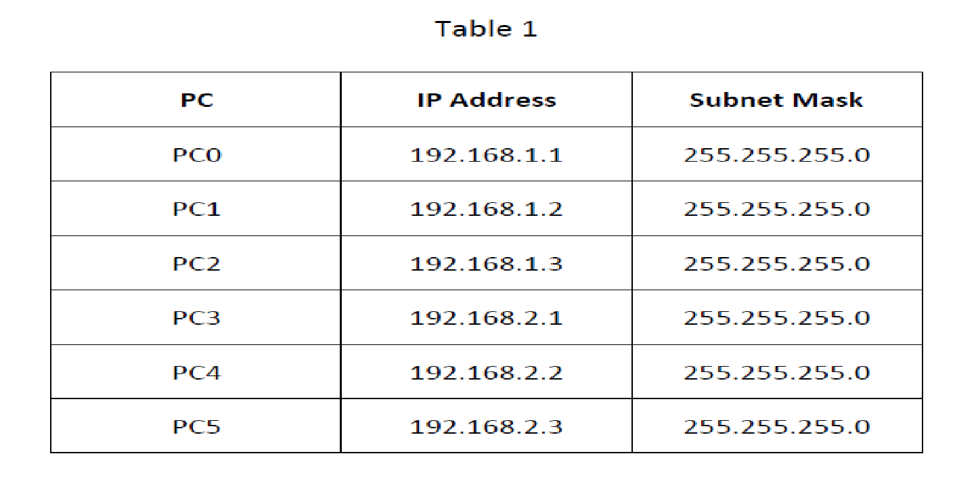

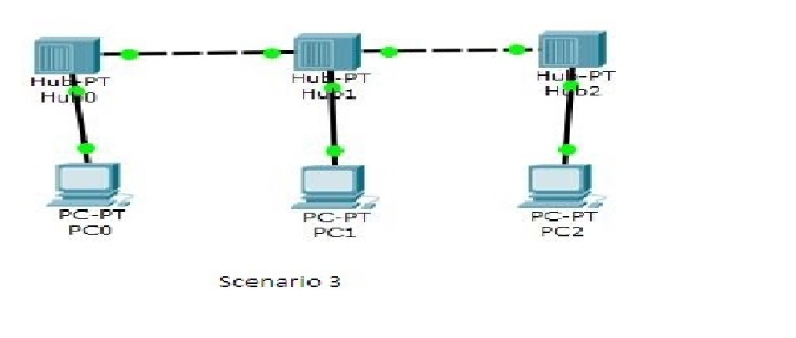

| PC | IP Address | Subnet Mask |
| --- | --- | --- |
| PC0 | 192.168.3.1 | 255.255.255.0 |
| PC1 | 192.168.3.2 | 255.255.255.0 |
| PC2 | 192.168.3.3 | 255.255.255.0 |

**Observations:**

**Scenario 1(Star Topology using Hub):**

Go to Simulation mode. In the Event List Filters, enable only ARP.

a) Using the “Simple PDU”, issue a ping from PC0 to PC1. Play the simulation using “Capture/Forward”. Pay close attention to how the hub processes the ARP packets.

b) After that, once again, use ”Add Simple PDU” to issue a ping from PC1 to PC0. Play the simulation again.

**Comment** on the ARP in case a) & b)

c) After that, once again, use ”Add Simple PDU” to issue a ping from PC2 to PC0 and from PC1 to PC0. Play the simulation again. Identify the difference in ARP packets in case b) & case a).

**Scenario 2(Star Topology using Switch):**

Go to simulation mode. In the Event List Filters, enable only ICMP and ARP.

1. Using “Add Simple PDU”, issue a ping from PC3 to PC4. Play the simulation. Pay close attention to how the switch processes the ICMP and ARP packets. Repeat the procedure for a ping from PC4 to PC5.
2. After that, once again, use “Add Simple PDU” to issue a ping from PC4 to PC3. Play the simulation again. Observe the behavior of the switch changed from the first and second ping attempts.

**Scenario 3(Bus Topology using Hub):**

Go to simulation mode. In the Event List Filters, enable only ICMP and ARP.

1. Using “Add Simple PDU”, issue a ping from PC0 to PC1. Play the simulation. Pay close attention to how the hub processes the ICMP and ARP packets. Repeat the procedure for a ping from PC1 to PC2.
2. After that, once again, use “Add Simple PDU” to issue a ping from PC2 to PC0. Play the simulation again. Observe the behaviour of the hub changed from the first and second ping attempts.

**Conclusion:** *(To be handwritten on journal sheets)*

**Post Experimental Exercise:**

*#STAR TOPOLOGY USING HUB*

* *To understand the star topology we constructed a small network with three generic pc ,one generic hub & connection wires.*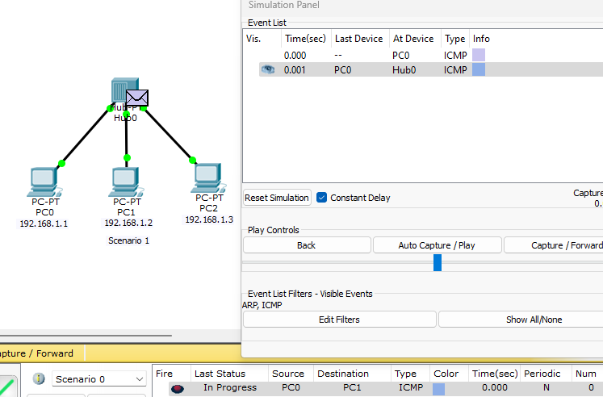

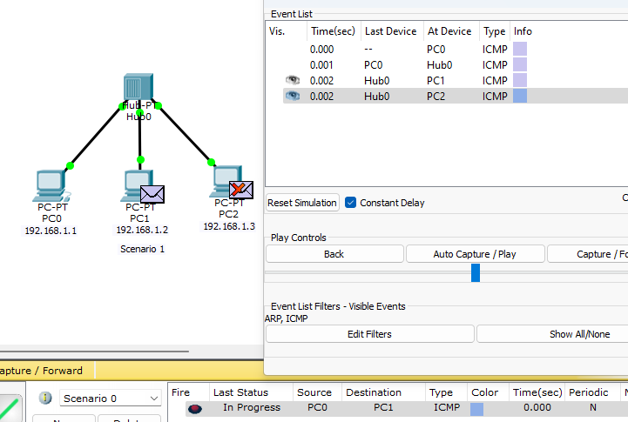

* *After configuring the network we started with the stimulation of packets from pc1 to pc3.*

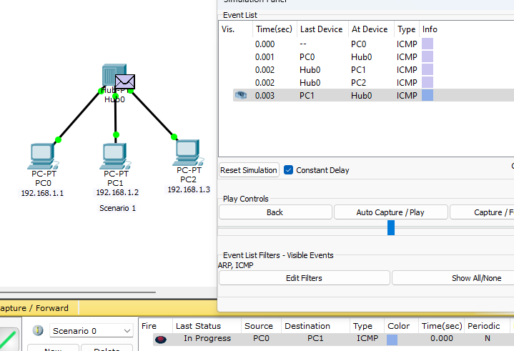

* *When a device sends data to the hub, the hub broadcasts that data to all other devices connected to it.*

*Depicts the simulation mode where ARP packets are filtered, displaying the process of pinging from PC0 to PC1 and vice versa.*

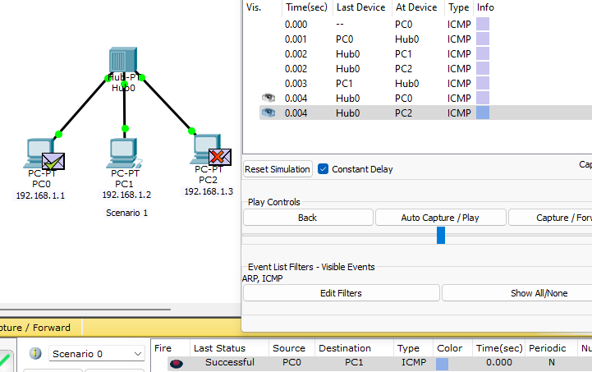

* *Continues the simulation by pinging from PC2 to PC0 and from PC1 to PC0, highlighting the differences in ARP packets.*

*#STAR TOPOLOGY USING SWITCH*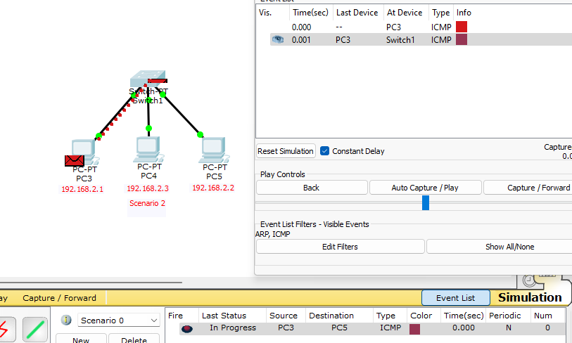

* *To understand the traversal of packets in star topology having switch , we constructed a small network on cisco with three generic pc ,one generic hub & connection wires.*

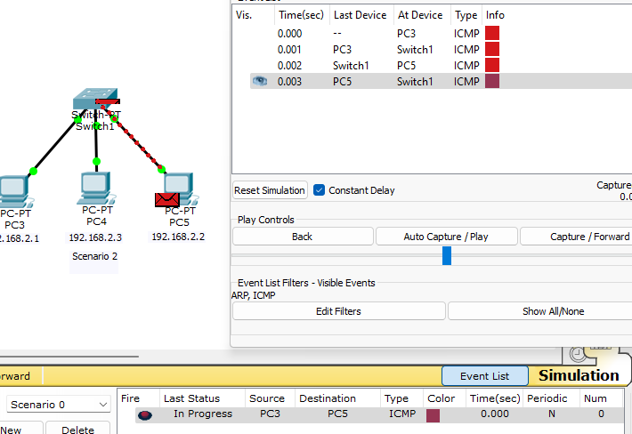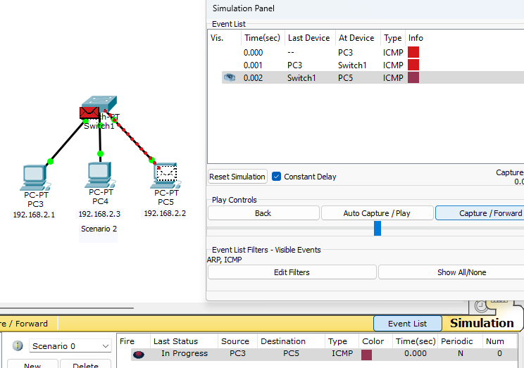

* *Once Provided the configuration details of PC0, PC1, and PC2 with their respective IP addresses and subnet masks.,we passed packets from pc3 to pc5 and switched to stimulation panel.*
* *When a device sends data to the switch, the switch examines the destination MAC address of the data packet and forwards it only to the port connected to the destination device.*

*Shows the simulation mode with ICMP and ARP packets filtered, demonstrating the pinging process between PC3 and PC4, and PC4 and PC5.*

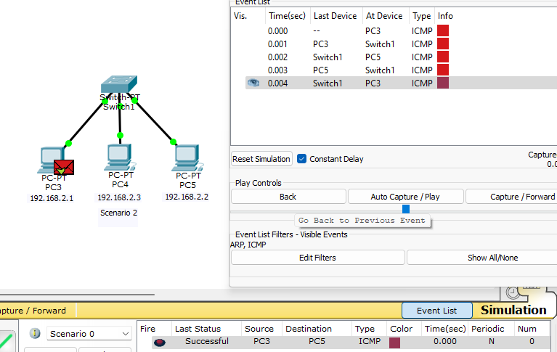

* *Continues the simulation by pinging from PC4 to PC3, observing the switch's behavior during different ping attempts.*

*#BUS TOPOLOGY USING HUB*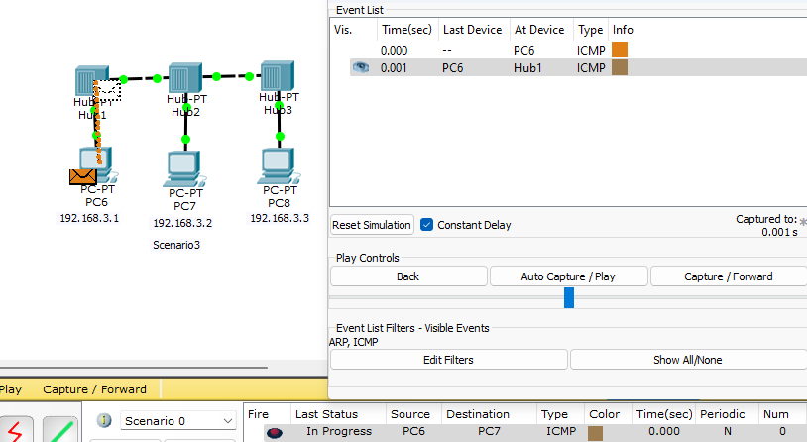

* *To understand the traversal of packets in bus topology having hub, we constructed a small network on cisco with three generic pc connected to three generic hub & connection wires.*

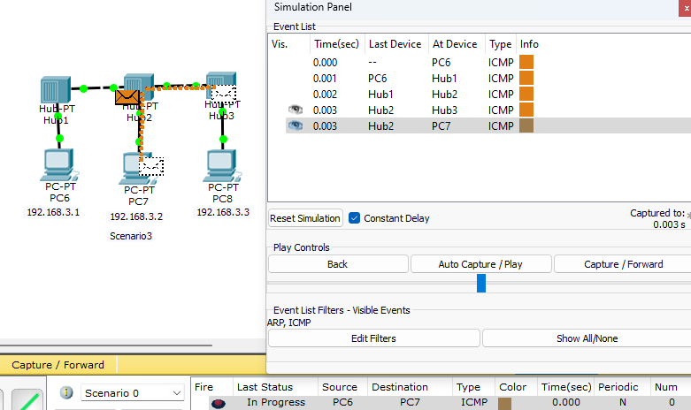

* *Once Provided the configuration details of PC6, PC7, and PC8 with their respective IP addresses and subnet masks.,we passed packets from pc6 to pc7 and switched to stimulation panel.*

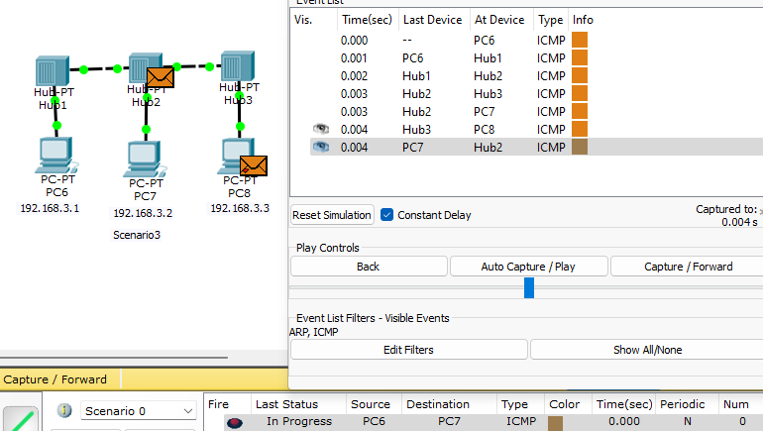

* *When a device sends data to the hub, the hub broadcasts that data to all other devices connected to it.*

*Displays the simulation mode with ICMP and ARP packets filtered, showcasing the pinging process between PC6 and PC7, and PC7 and PC8*

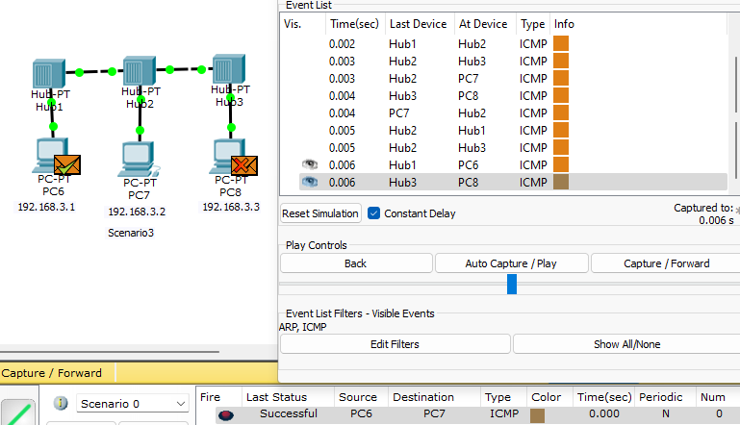

* *Continues the simulation by pinging from PC8 to PC7, highlighting the hub's behavior during different ping attempts.*

*#MESH TOPOLOGY USING HUBS*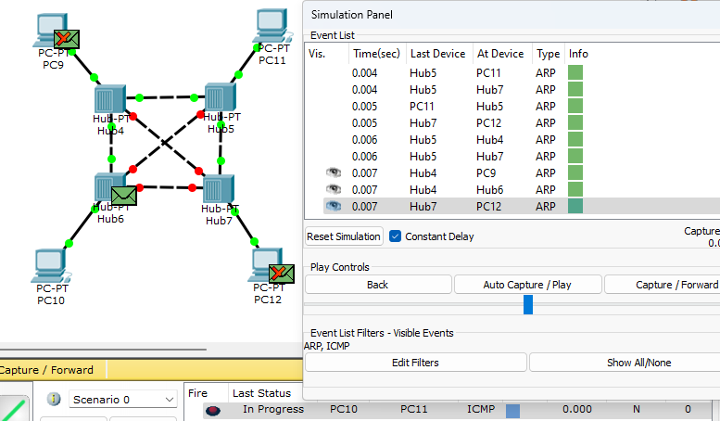

* *To understand the traversal of packets in mesh topology having hub, we constructed a small network on cisco with four generic pc connected to four generic hub & connection wires to connect all these hubs and pcs*

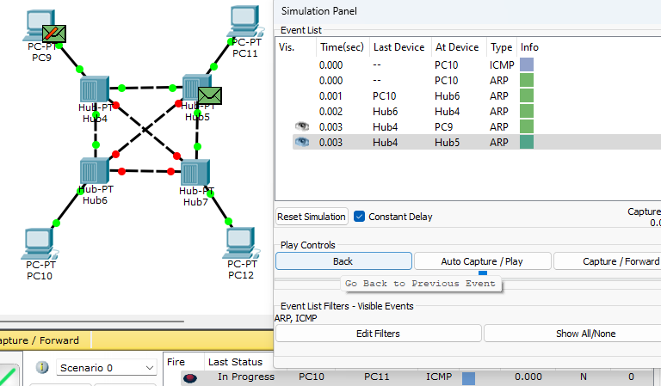

* *Once Provided the configuration details of PC9, PC10, and PC11 and PC12 with their respective IP addresses and subnet masks.,we passed packets from pc10 to pc9 and switched to stimulation panel.*

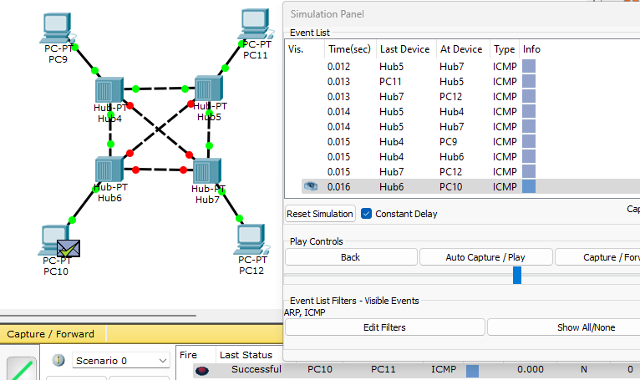

* *All the hubs broadcast the data sent by the sender pc to all the pc connected in the network and hence the pc which is receiver responds and other pcs reject such unwanted data.*

*#MESH TOPOLOGY USING SWITCHES*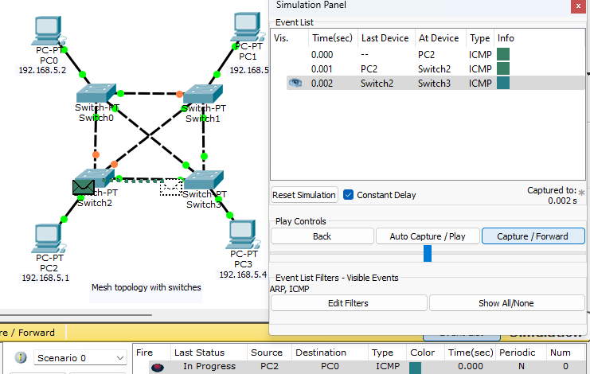

* *To understand the traversal of packets in mesh topology having switches, we constructed a small network on cisco with four generic pc connected to four generic hub & connection wires to connect all these hubs and pcs together.*

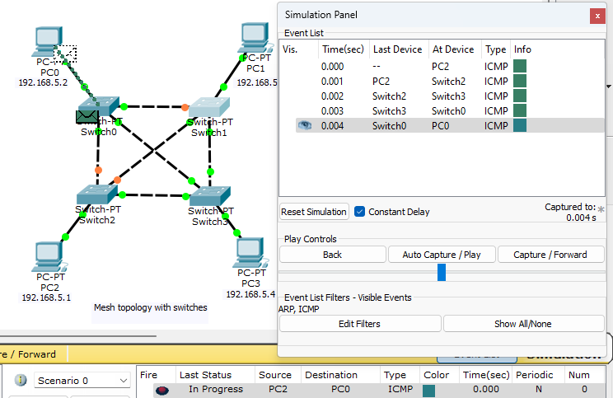

* *Once Provided the configuration details of PC0, PC1, and PC2 and PC3 with their respective IP addresses and subnet masks.,we passed packets from pc2 to pc0 and switched to stimulation panel.*

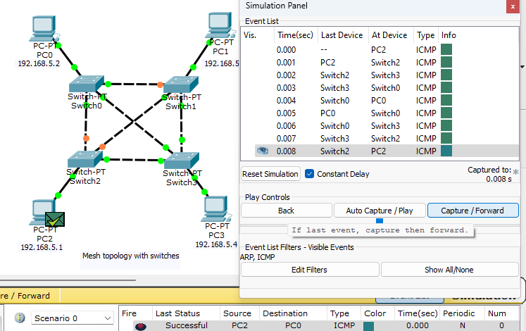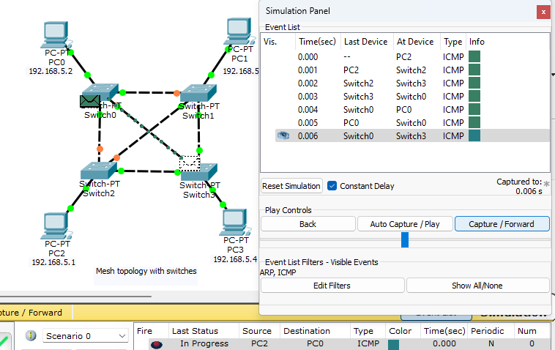

* *When a device sends data to the switch, the switch examines the destination MAC address of the data packet and forwards it only to the port connected to the destination device.*
* *Hence in this case switches on the network has examined that the data sent from pc2 is supposed to be received by a pc having mac address 192.168.5.2 i.e pc0.Hence data is received without being broadcasted on network.*